THE UNIVERSITY OF AZAD JAMMU & KASHMIR, MUZAFFARABAD


COURSE TITLE | SDA
COURSE CODE | SE-2102
LAB TITLE | SEQUENCE DIAGRAM
STUDENT NAME | HASEEB SHEIKH
STUDENT ROLL NUMBER | 2024-SE-31
INSTRUCTOR NAME | ENGR. DANIYAL NAZIR
SUBMISSION DATE | DECEMBER 4, 2025

DEPARTMENT OF SOFTWARE ENGINEERING
SDA
Lab 5

1. Objective
To understand and document the flow of interactions between different system components in an Online University Course Management System using a sequence diagram. The experiment focuses on course enrollment, assignment submission, grading, payments, and notifications.

2. Actors Involved
- Student – initiates actions such as enrollment and submission.
- Course Management System (CMS) – central system controlling all processes.
- Admin – approves or rejects course enrollment.
- Payment Gateway – handles payment transactions.
- Professor – evaluates assignments and uploads grades.
- Notification Service – sends emails and alerts.

3. Theory
A Sequence Diagram is a behavioral UML diagram that represents the chronological order of messages exchanged between actors and system components.
It helps understand:
- How actions begin
- What messages are exchanged
- The order of operations
- How exceptions are handled
Sequence diagrams are especially useful for visualizing real-time system behavior.

4. Procedure

A. Course Enrollment Process
- Student logs into the CMS.
- Student selects a course to enroll.
- CMS checks if the course is available.
- CMS sends an approval request to the Admin.
- Admin approves or rejects the request.
- If approved, CMS requests payment from the Payment Gateway.
- Payment status is returned to CMS.
- CMS finalizes the enrollment.
- Notification Service sends an enrollment confirmation to the Student.

B. Assignment Submission Process
- Student uploads an assignment through the CMS.
- CMS verifies the file format and stores the submission.
- CMS informs the Professor that a new assignment is available.
- Professor checks and evaluates the assignment.
- Professor submits grades back to the CMS.
- CMS records the grade in the Student’s profile.
- Notification Service sends a grade notification email to the Student.

C. Exception / Error Handling
- Payment Unsuccessful:
CMS cancels enrollment and alerts the Student to retry.
- Invalid Assignment File:
CMS notifies the Student to upload a correct file.
- Delayed Grading:
CMS automatically sends a reminder to the Professor.

5. Sequence Diagram Description (Text Explanation)
The sequence diagram illustrates the interaction between the Student, CMS, Admin, Payment Gateway, Professor, and Notification Service.
It demonstrates:

Enrollment Flow:
The Student initiates enrollment. The CMS interacts with Admin for approval and Payment Gateway for fees. After successful completion, a confirmation is sent.

Assignment Flow:
Assignment movement begins with the Student uploading the file. The CMS handles validation, passes it to the Professor, and handles the final grading communication.

Exception Flow:
Any errors such as failed payments or invalid files are handled by CMS, and appropriate notifications are sent.

Output:

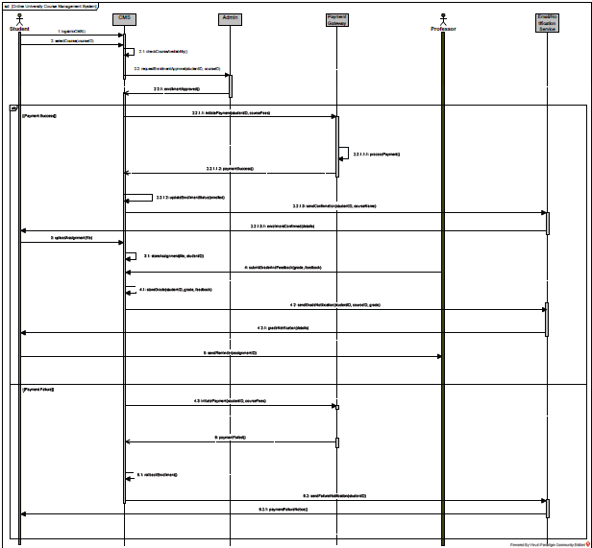

6. Conclusion
The sequence diagram clearly represents the complete workflow of course enrollment and assignment submission in OCMS.
This experiment helps understand the messaging order, interactions, and exception flow within a dynamic system.

